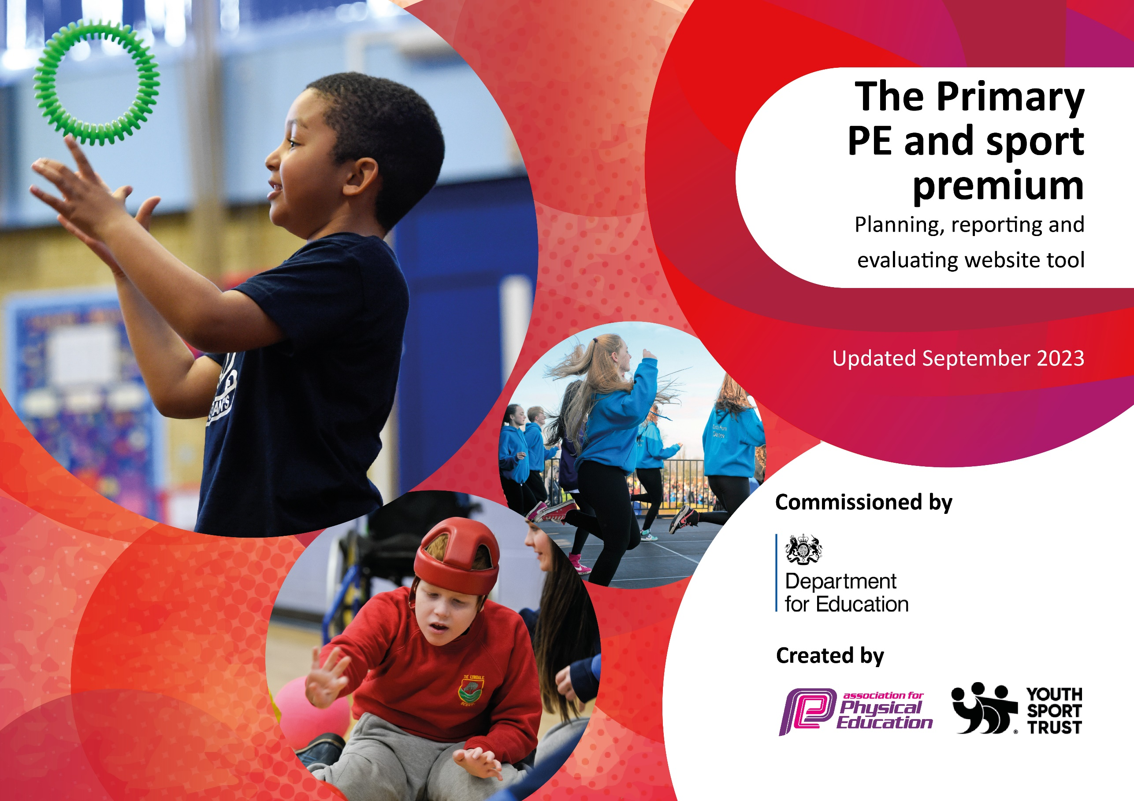

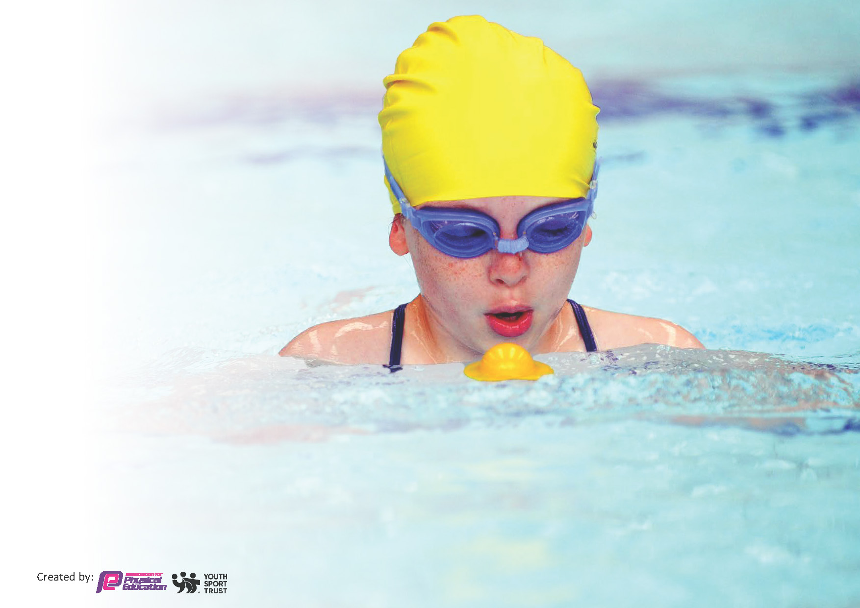
This template can be used for multiple purposes:
by:
- It enables schools to effectively plan their use of the Primary PE and sport premium
- It helps schools to meet the requirements (as set out in guidance) to publish information on their Primary PE and sport premium
- It will be an effective document to support Ofsted inspections enabling schools to evidence progress in Physical Education (PE) and evidence swimming attainment, which forms part of the PE National Curriculum. We would recommend schools consider
the Intent, Implementation and Impact of any spend, as examined within the Education Inspection Framework.

It is important that your grant is used effectively and based on school need.

Schools must use the funding to make additional and sustainable
improvements to the quality of the PE, School Sport and Physical Activity (PESSPA)
they offer. This means that you should use the Primary PE and sport premium to:

- Build capacity and capability within the school to ensure that improvements made now will benefit pupils joining the school in future years
- Develop or add to the PESSPA activities that your school already offers.

The Primary PE and sport premium should not be used to fund capital spend projects; the school’s core budget should fund these. Further detail on capital expenditure can be found in the updated Primary PE and sport premium guidance.

The Primary PE and sport premium guidance, outlines 5 key priorities that funding should be used towards. It is not

necessary that spending has to meet all the key priorities, you should select the priorities that you aim to use any funding towards.

Although completing this template is not a requirement for schools, schools are required to publish details of how they spend this funding. Schools must also outline what the impact this funding has had on pupils’ PE and sport participation and attainment and how any spending will be sustainable in the future. All funding must be spent by 31st July 2024.

The Department for Education has worked closely with the Association for Physical Education (afPE) and the Youth Sport Trust (YST) to develop this template and encourages schools to use it. This template is an effective way of meeting the reporting requirements of the Primary PE and sport premium.
Review of last year’s spend and key achievements (2022/2023)

We recommend you start by reflecting on the impact of current provision and reviewing your previous spend.

Activity/Action | Impact | Comments
- Continue to hire a Sports Coach to lead and organise active break times and lunch times. £7,600  - After school clubs each day £2,470  - PE lessons across the school taught by a Sports Coach £7,600  - Increase the level of fitness and stamina of pupils- identified  - Training for Playleaders  - Membership for Chester SSP £1,200  - To gain Platinum Mark status – tournaments - £120  - Audit and ordering of sports equipment to enhance provision within PE sessions -£500  - Swimming lessons with transport for Y3/4/5 and non swimmers in Y6 £4798 | - Support healthy, active break times in school. Encourage children to practise PE skills in break time.  - The school is able to provide a wide range of extra-curricular activities.  - The PE curriculum is further enhanced and developed through having a specialist PE coach supporting the teaching.  - Staff skills are developed through working with a sports coach.  - Pupils are motivated through working with a sports coach.  - Pupils are signposted to sports clubs in their local area.  - Pupils have the opportunity to lead play activities and hold an area of responsibility.  - Through membership of Chester SSP, St Clare’s has access to a wide range of sporting opportunities.  - St Clare’s has received the Gold Schools Active Award for the last four years.  - The majority of children can swim at least 25m by the time they leave St Clare’s. | - Active playtimes have become part of the school offer for playtime. There is a need for more equipment.  - Extra-curricular clubs are not always well attended.  - PE specialist teacher has not been consistent with three different coaches across the year.  - Sports coach has covered PPA and not had the opportunity to work with staff.  - Pupils have been signposted particularly through hockey and football pathways.  - Play Leaders trained and actively leading play on KS1 playground. CEDP staff leading active breaktimes.  - St Clare’s accessed all opportunities to enter competitions and won Primary School Team of the Year for our Hockey Team.  - St Clare’s achieved Platinum Sports award.  - The majority of children could swim at least 25m by the time they left Y6 through the use of top up swimming and lessons for all pupils in Y3 – Y5.

Key priorities and Planning
This planning template will allow schools to accurately plan their spending.

Action – what are you planning to do | Who does this action impact? | Key indicator to meet | Impacts and how sustainability will be achieved? | Cost linked to the action
Continue to hire a Sports coach to lead and organise active break and lunch times, setting up systems to allow for sustainable change. | Midday assistants, CEPD coaches – they will lead the activities.  Pupils – they will take part. | Key indicator 2 – increasing engagement of all pupils in regular physical activity and sport.  Key indicator 4: Broader experience of a range of sports and activities offered to all pupils. | More pupils meeting their daily physical activity goal, more pupils encouraged to take part in PE and Sport Activities. | £6,080 costs for additional coaches to support lunchtime sessions.

PE lessons to be taught by a specialist coach.  After school sports clubs delivered by specialist teachers.  Hire a swimming pool, lifeguard and instructors to deliver PE lessons.  CSSA and SPP membership for the school | Pupils as they will receive specialist teaching.  Staff as they observe outstanding teaching.  Pupils - they are given the opportunity to participate in a range of sports more competitively.  Pupils – they are given the opportunity to learn how to swim over a distance, using different strokes and taught water safety.  Pupils – they are given access to festivals and the opportunity to participate competitively.  Staff- staff are upskilled through their participation in the festivals and competitions by watching expert teachers. | Key Indicator 1: Increasing all staff’s confidence, knowledge and skills in teaching PE and sport.  Key Indicator 2: Increased engagement of all pupils in regular physical activity and sport.  Key Indicator 3: Raising the profile of PE and sport across the school, to support whole school improvement.  Key Indicator 5: Increase participation in competitive sport.  Key Indicator 2: increasing engagement of all pupils in regular physical activity and sport.  Key Indicator 4: Offer a broader and more equal experience of a range of sports and physical activities to all pupils.  Key Indicator 3: raising the profile of PE and sport across the school, to support whole school improvement.  Key Indicator 1: Increasing all staff’s confidence, knowledge and skills in teaching PE and sport.  Key Indicator 2: Increased engagement of all pupils in regular physical activity and sport.  Key Indicator 3: Raising the profile of PE and sport across the school, to support whole school improvement. | The PE curriculum is enhanced by a specialist coach delivering lessons.  Children are able to improve their mental health and wellbeing by participating in sports.  The pool is on school site for a number of weeks and children are taught more intensely allowing them to make more rapid progress.  Through engagement with the memberships, we are instilling positive attitudes to sport for our pupils which will be lifelong. We aim for every pupil in UKS2 to represent the school. | £6,080 for the coach to deliver the lessons.  £6,080 for the coach to deliver the clubs.  £9,120 to hire the pool, lifeguard and coach.  £1.770 membership fees.

Key achievements 2023-2024
This template will be completed at the end of the academic year and will showcase the key achievements schools have made with their Primary PE and sport premium spending.

Activity/Action | Impact | Comments

Swimming Data
Meeting National Curriculum requirements for swimming and water safety.
Priority should always be given to ensuring that pupils can perform safe self-rescue even if they do not fully meet the first two requirements of the National Curriculum programme of study

Question | Stats: | Further context  Relative to local challenges
What percentage of your current Year 6 cohort can swim competently, confidently and proficiently over a distance of at least 25 metres? | %
What percentage of your current Year 6 cohort can use a range of strokes effectively [for example, front crawl, backstroke, and breaststroke]? | %

What percentage of your current Year 6 cohort are able to perform safe self-rescue in different water-based situations? | %
If your schools swimming data is below national expectation, you can choose to use the Primary PE and sport premium to provide additional top-up sessions for those pupils that did not meet National Curriculum  requirements after the completion of core lessons. Have you done this? | Yes/No
Have you provided CPD to improve the knowledge and confidence of staff to be able to teach swimming and water safety? | Yes/No

Signed off by:

Head Teacher: | Lucy Ward
Subject Leader or the individual responsible for the Primary PE and sport premium:
Governor: | (Name and Role)
Date:

